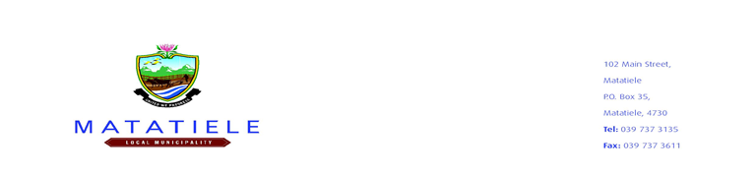

**Matatiele Local Municipality**

**Bid Notice**

Bidders are hereby invited to submit their tenders for the following priority projects:

|  |  |  |  |
| --- | --- | --- | --- |
| **BID NUMBER** | **PROJECT NAME** | **ADVERT DATE** | **CLOSING DATE** |
| **MATAT/2022/2023-0177** | **SUPPLY AND DELIVERY OF ONE (1) NEW 16-SEATER MINIBUS VEHICLE** | **24 FEBRUARY 2023** | **13 MARCH 2023 @10H00** |

**MANDATORY DOCUMENTS AS LISTED IN THE TENDER TO BE SUBMITTED, FAILURE TO DO SO WILL RESULT IN THE BID BEING DEEMED TO BE NON-RESPONSIVE**

Matatiele Local Municipality Supply Chain Management policy will apply. A confirmation from SARS with a verification PIN, Proof of Central Supplier Database (CSD) registration- a full updated report (printed), Completion of MBD 1-9 and its Annexures in full. Prices quoted must be firm and must be inclusive of VAT. Original Certified I.D. Copies of Managing Directors / Owners. Joint Ventures will only be accepted if all necessary requirements as per tender document are met.

**EVALUATION CRITERIA**

The Bids will be evaluated on the basis of the Preferential Procurement Policy Framework Act is 80/20 in line with the Preferential Procurement Policy Framework Act (PPPFA) of November 2022.

Bids will be awarded points on the following basis:

**1. Tender Price 80 points**

**2. HDI – Equity ownership 6 points**

**3. Youth-Enterprises 0-35 years (MLM) 6 points**

**3. Women – Equity ownership 4 points**

**4. Disability – Equity ownership 2 point**

**5. Rural Enterprises (MLM) 2 points**

**TOTAL 100 points**

**OBTAINING OF TENDER DOCUMENTS:**

Bid Documents will be available as from 28 February 2023 at the Municipal Website and BTO Offices for a non – refundable tender fee of R500 for payable in the Municipal bank account (Ned Bank 1011292106 branch code 198765, name of company and bid no as reference) (Failure to attached proof of purchase will lead disqualification). To obtain tender documents please login to www.matateiele.gov.za or email nngcobo@matatiele.gov.za.

The Matatiele Local Municipality reserves the right not to appoint a contractor on highest points scored. Value for money and past experience will be the key determinants of appointment. All tenders must be deposited in the tender box situated **at the Matatiele Local Municipality, Matatiele, Eastern Cape 4730** reception area not later than 10h00 noon as per provided closing dates, where they will be opened in public. All tenders must be clearly marked “Name of the project indicated above”. *The Municipality will not make any award to a person or persons working for the state, or failing to possess relevant credentials as stipulated in the tender requirements.* **Each Bid must be submitted separately**

**Bidders are warned not to accept any person who request any amount for award for this bid, it is a scam and fraud, that person must be reported to the nearest police station.**

All SCM enquiries relating to this bid must be directed to Z.C Matolo, e-mail: zmatolo@matatiele.gov.za during office hours (07h30 – 16h00) weekdays. All Technical enquiries relating to this bid must be directed to Ms M Sabasaba, e-mail: msabasaba@matatiele.gov.za during office hours

_______________________

**Mr L.Matiwane**

**Municipal Manager**