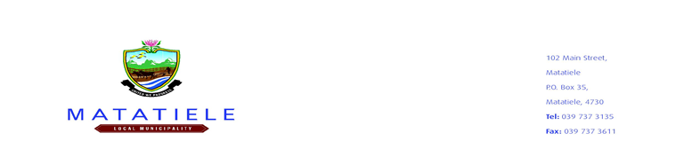

**ERRATUM**

The Matatiele Local Municipality would like to inform all the prospective bidders of the changes below which relate to the below notice:

|  |  |  |  |  |  |
| --- | --- | --- | --- | --- | --- |
| **BID NO** | **DESCRIPTION** | **CIDB REQUIRED** | **ADVERTISING DATE** | **NEW**  **REQUIREMENT** | **CLOSING DATE** |
| **2022/2023-123** | **SUPPLY AND DELIVERY OF BRICKS EQUIPMENT**  **AND ELECTRICITY UPGRADE** | **1 EP OR HIGHER** | **19 OCTOBER 2022** | **MBD 6.2 For Local Production and Content Local content 100% of Steel Products and Components for Construction and 100% Electrical cables and annexure C, D and E will result in the tender being eliminated** | **26 OCTOBER 2022 @ 10H00** |

The municipality would like to apologize for any inconvenience caused and other information remains unchanged.

SCM enquiries should be directed to Mr. Z Matolo (Manager: SCM) at ZMatolo@matatiele.gov.za during office hours.

------------------------------

**MR. L. MATIWANE**

**MUNICIPAL MANAGER**